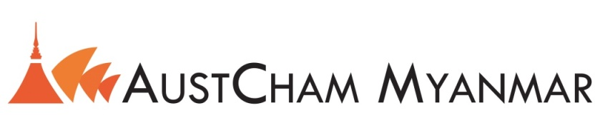

**Member to Member Discount Program Application**

AustCham Myanmar’s Member to Member Discount Program offers member businesses and their employees discounts on products or services from other AustCham Myanmar members. Chamber members can use this service by offering a discount and/or taking advantage of these discounts.

The Program is free and available only to members of AustCham Myanmar.

Please fill out the following application to indicate the discount your business would like to provide to other members.

* Discounts must be available to all AustCham Myanmar members and their employees.
* Discounts must be a minimum of 10%.
* Discounts must apply to goods and services.
* Participants are responsible for updating their offer on an as needed basis.
* Descriptions will be limited to 50 words or less.

|  |  |
| --- | --- |
| Company Name: |  |
| Contact Person: |  |
| Address: |  |
| Phone: |  |
| Email: |  |
| Description of the discount offered (50 word maximum) |  |
| Restrictions/Expiration Date: |  |

**Signed on Behalf of**

Signature:

Name:

Date:

**Signed on Behalf of AustCham Myanmar**

Signature:

Name:

Date:

cc

cc

For more information, please email [info@a-mcc.com](mailto:info@a-mcc.com)